**Appendix to Practice Paper**

Question 1:

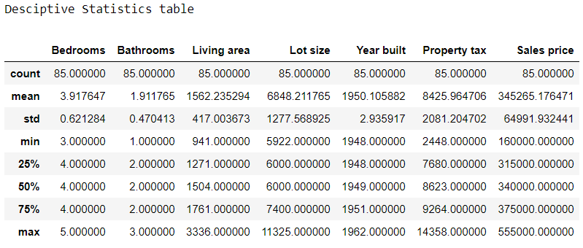

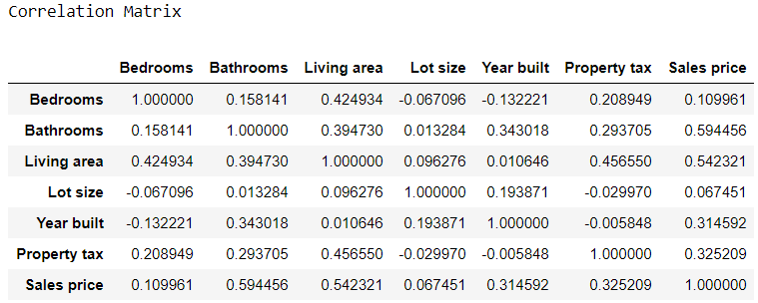

Summary output of the regression model:

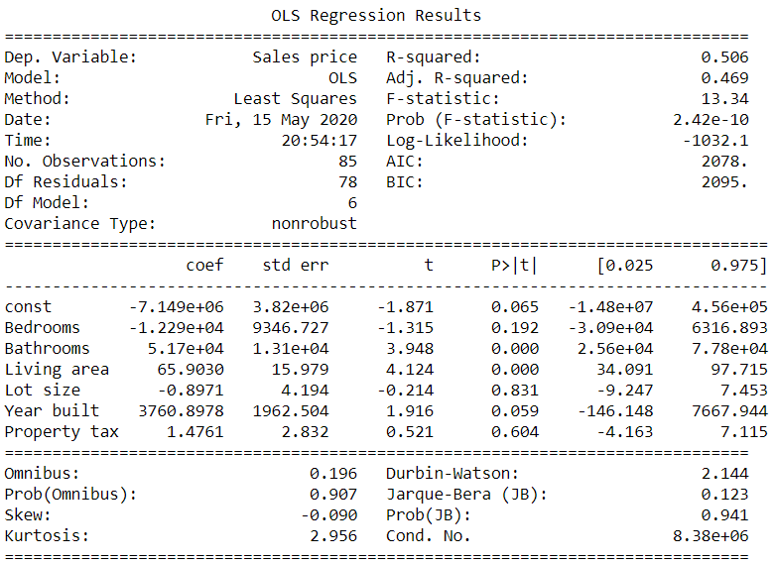

Question 2:

Summary output of the regression model:

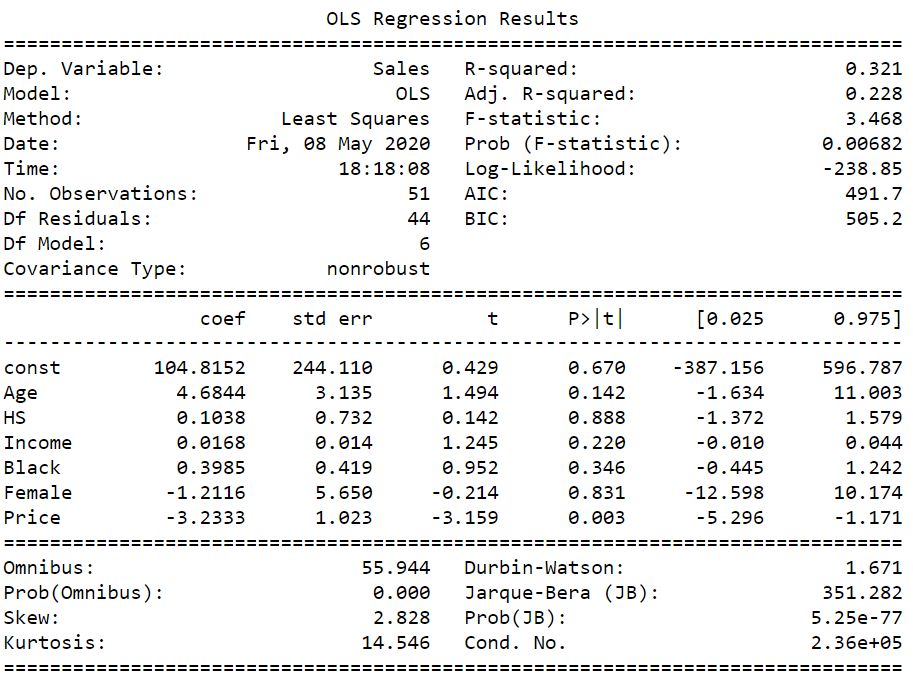

Residual plots:

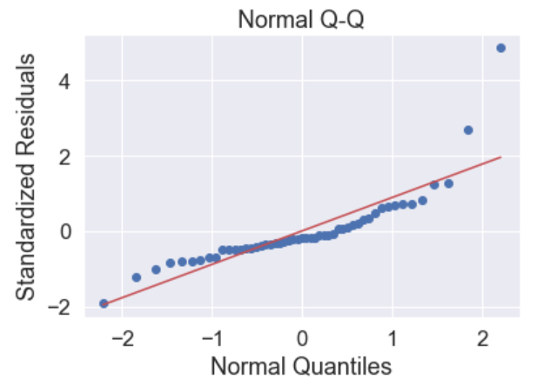 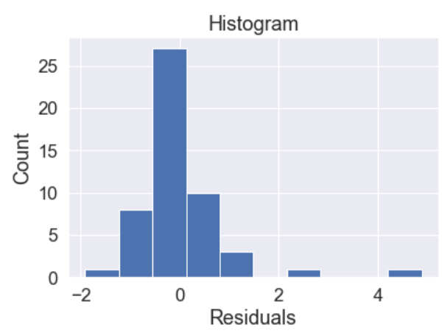

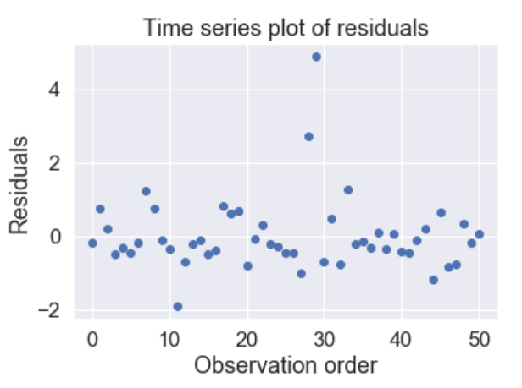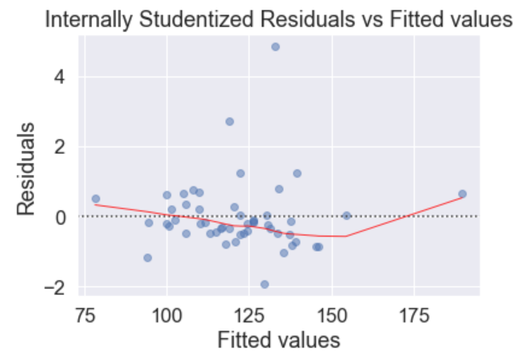

VIF table:

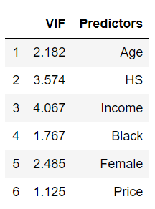

Question 3:

Model 1 summary:

Model 1 residual plots:

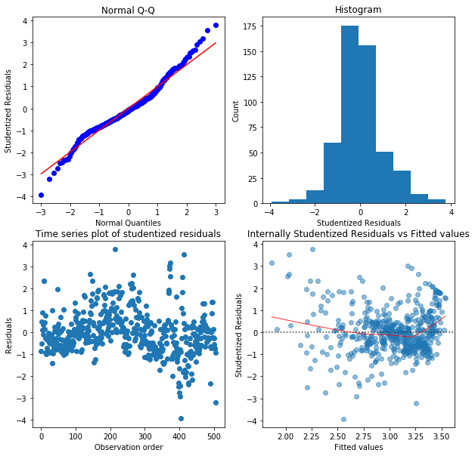

Model 2 summary:

Model 2 residual plots:

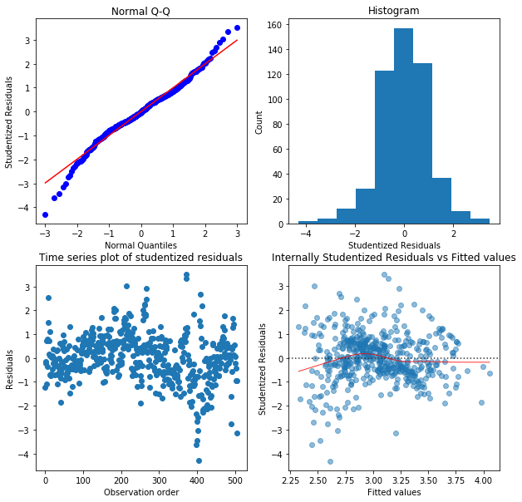

Question 4:

Summary output of the regression model

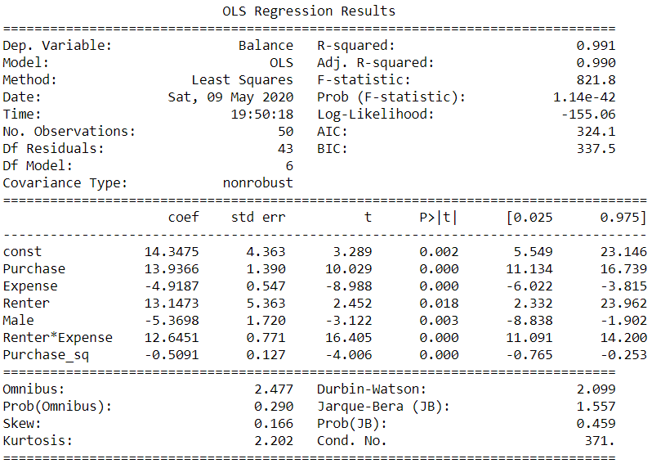

Question 5:

Summary of all possible models:

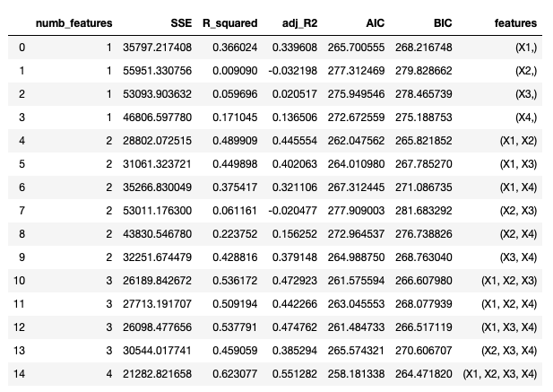

Question 6:

Trained model in leave one out CV for model A:

1st

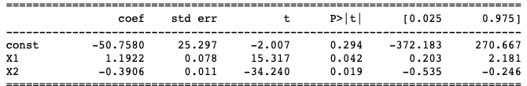

2nd

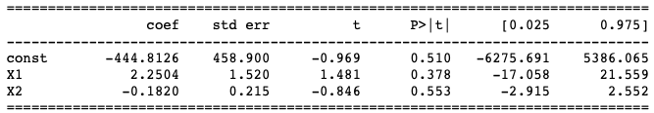

3rd

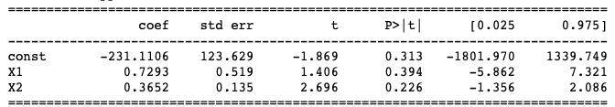

4th

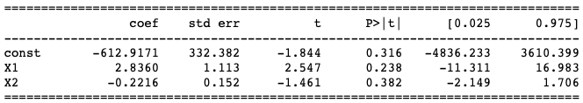

5th

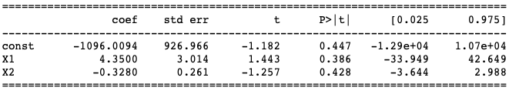

Trained model in leave one out CV for model B:

1st

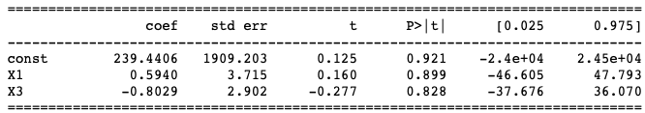

2nd

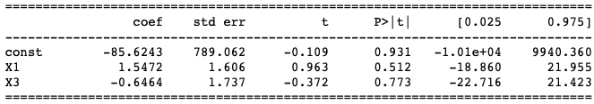

3rd

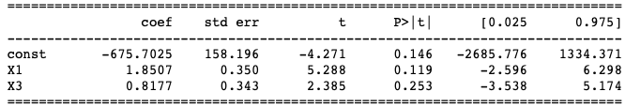

4th

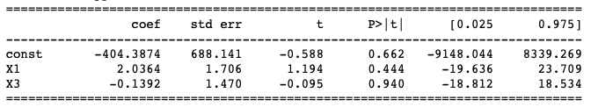

5th

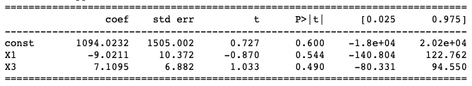

Question 7:

Summary output:

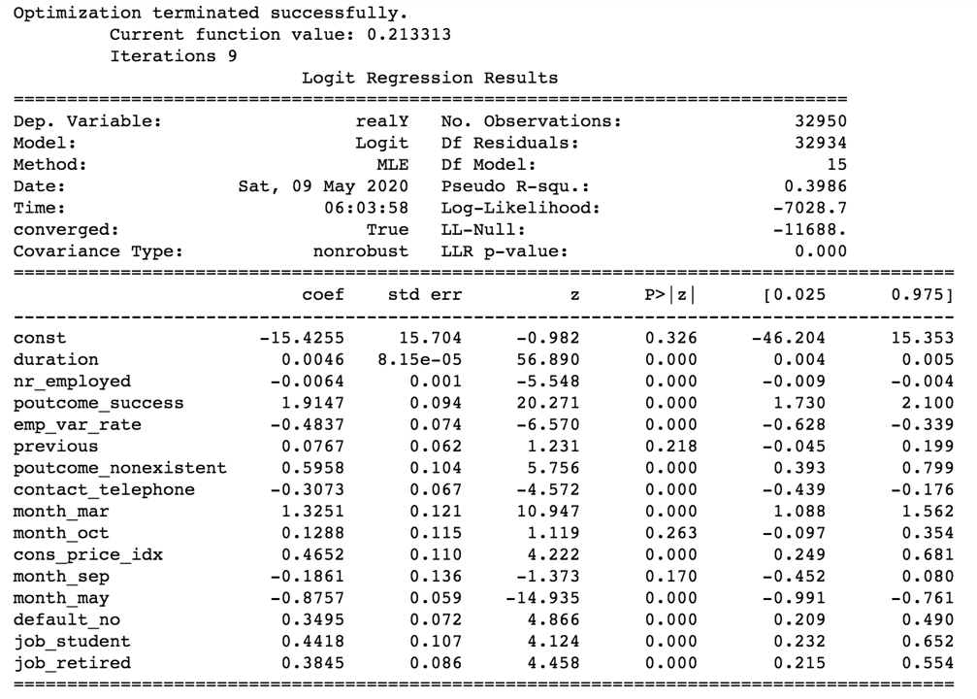

Question 8:

Confusion table:

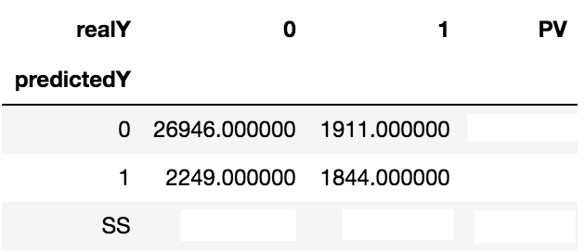

KS chart:

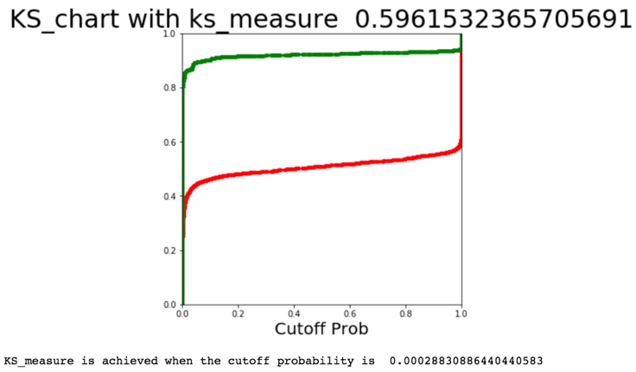

Question 9:

Data: Labels: Elbow plot:

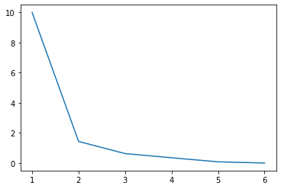 

Question 10:

Data:

